**ASSIGNMENT- Strategic Planning**

**Topic- Honda Canada Inc.**

**Baishali Kakati (200567296)**

**Manpreet Kaur( 200554128)**

**Gurwinder Singh (200557497 )**

**Sukhminder Kaur (200582090 )**

**Georgian College**

**Human Resource Planning- HRMN1016**

**Dr. Sara Ashwood**

**Date- 30/07/2024**

**EXECUTIVE SUMMARY OF HONDA CANADA INC.:**

**Company Overview-** HondaCanada Inc. is a branch of Honda Motor Co., Ltd., which is a Japanese Multinational Corporation, established in 1969. It is known for manufacturing automobiles, and motorcycles and has been building cars in Canada since 1986 in Alliston, Ontario and headquarters in Markham, Ontario (*Our Company – Honda Canada Manufacturing*, n.d.).

Honda Canada is a leading company in the Canadian car market, ranking higher in sales and customer satisfaction. The Honda Civic has been a top-selling car in Canada for more than twenty years according to a study by (*Our Products – Honda Canada Manufacturing*, n.d.).

Shinji Aoyama, the Honda Company's director, executive vice president, and representative executive officer, claims that the company's business goal is to “aim to expand their economic value by pursuing social value and chart a new growth trajectory as a company” (*Corporate Strategy | Integrated Report「Honda Report 2023」| Honda Global Corporate Website*, n.d.)



**Strategic Initiatives:**

1. **Sustainability and Innovation:**
   * Honda Company dedicatedly work towards protecting the environment and effecting it as less as possible. They focus on making fuel- efficient and low- emission vehicles, which includes electric models and hybrids.
2. **Customer Experience:**
   * For them, customer service plays a crucial role to enhance their knowledge in what people want, therefore, they provide online sales platforms and virtual showrooms including digital transformation to ensure high levels of satisfaction and loyalty.
3. **Manufacturing Excellence:**
   * Honda specifically focuses on high quality manufactures and precise production techniques to provide efficiency and zeal. It executes two production plants in Alliston, Ontario, manufacturing vehicles and engines for the Canadian market and to export as well.

**Financial Performance:** Honda Canada performs strongly in financial terms by increasing its revenue and profits with consistency and by managing costs well and making strategic investments which helped them maintain stability in finance and in the market with success.

**Corporate Social Responsibility (CSR):** Honda Canada actively participates in community services and in protection and prevention of environmental conservations by supporting various programs aiming education, environmental sustainability, building roads and its safety concerns.

‘Honda, in positioning itself as an environmentally friendly car company, has created a slogan to reflect its commitment to building a safer world for future generations of boys and girls: "Blue Skies for Our Children" (Fracassa, 2018).

**Challenges and Opportunities:**

**Challenges:** After the rise of electric vehicles (EVs), Honda Canada is going through disruptions due to changing preferences of people and issues of global supply chains (*Honda in Canada: Our Mission & Corporate Responsibility*, n.d.-b)

**Opportunities:** Honda Canada can invest enormous amount on the growing manufacture of electric vehicles and hybrid transportation solutions for sustainability. Their research and development skills and strong brand reputation can continue innovation and broaden its market value in the evolving landscape of automobiles (*Honda in Canada: Our Mission & Corporate Responsibility*, n.d.-c)

**Redefining the Honda Global Brand Slogan**  
During the major changes taking place in the automotive industry, Honda’s management decided to redefine their existing brand slogan- THE POWER OF DREAMS to describe its core purpose that is beyond the creation of business strategies like electric vehicles and digital technology but what it actually aims and what makes Honda valuable with a new tagline and three key words to reflect its focus better:

* **How we move you.**  
  The creation of mobility through the dreams of each and every Honda associate will “move” people physically and also “move” people’s hearts. (*Honda in Canada: Our Mission & Corporate Responsibility*, n.d.-c)

**Create, Transcend, Augment**  
The company aims to create the kind of movement that every employee who are powered with dreams and motivation in the Honda company which means creating products and services that overcome the limit of time and space and grow their opportunities that help people. The three words CREATE, TRANSCEND, AUGMENT provides the meaning of the vision, Honda hopes to achieve to inspire people and provide progress in the society (*Honda in Canada: Our Mission & Corporate Responsibility*, n.d.-c)

).

**COMPANY DESCRIPTION:**

The purpose of Honda Canada Inc., is to build vehicles for the people of Canada right at home and to export outside Canada. Honda Canada with its family and Acura, together employs approximately 19000 people from coast to coast. Honda’s purpose is broader than just to provide innovative vehicles and make huge investment but it aligns with the mission and vision of the company which focuses more on innovations, mobility growth, sustainability and improving the life quality of consumers and the communities(*Honda in Canada: Our Mission & Corporate Responsibility*, n.d.-c).

Honda Canada is the parent company for both Honda and Acura automobile brands in Canada and was established in 1969. Since 1986, they produced Honda engines and its 10 millionth car in 2023 and light trucks at Alliston, Ontario, where the Honda Civic and Honda CR-V are currently manufactured. Honda Canada has invested over $6.5 billion in goods and services from Canadian suppliers. The plant size of Honda Canada is 4 million square feet and the site size is 890 acres. There are a total of 4200 associates working in Honda Canada (*Honda in Canada: Our Mission & Corporate Responsibility*, n.d.-c).

**MISSION, VISION AND VALUE STATEMENTS OF HONDA CANADA INC.:**

MISSION: Honda mission statement is “**maintaining a global viewpoint, we are dedicated to supplying products of the highest quality, yet at a reasonable price for worldwide customer satisfaction**” (Msa, 2020). It basically mentions about the improvement of life and improving affordability. priorities. The company values the supplies of its products and listed it to their top priorities.

VISION: The 2030 vision statement of Honda Canada ensures that they will bring the universal passion of Honda to “serve people worldwide with the joy of expanding their life’s potential.” And toward this end, they will “lead the advancement of mobility and enable people everywhere in the world to improve their daily lives” (*Vision | Brand | About Honda | Honda Global*, n.d.). The vision of the company is to maximize the advancement of mobility and value creation for people’s daily lives.

CORE-VALUE: The value statement of Honda company covers up “Respect for the individual” which includes **initiative** that means not bound under preset ideas but encourage enough to think creatively and act upon one’s own initiative and decision while understanding the fact that one must take responsibility of their own actions; **equality** that means to identify and respect individual opinions and differences irrespective of education, colour, status, religion, gender and treat everyone fairly; **Trust** among the associates who are employed in Honda and helping each other with good conscience and sharing knowledge for a better tomorrow and “the three joys” ((*Honda Philosophy | Brand | About Honda | Honda Global*, n.d.) 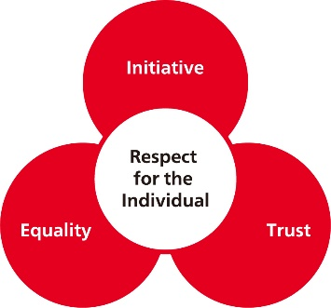

**The Three Joys** (*Honda Philosophy | Brand | About Honda | Honda Global*, n.d.)

The Joy of Buying: Joy of buying is felt after providing the relevant products and services to the customers and fulfil them with their expectations and needs.

The Joy of Selling: Joy of selling is achieved by the employees who are engaged in selling products and provide services to customers based on mutual trust. The dealers and distributors too experience a feeling of satisfaction when they can make a customer trust their product and value of it through facts and make them a loyal customer of Honda.

The Joy of Creating: Joy of creating occurs when Honda associates have created a design and developed and engineered before manufacturing the Honda product to provide the best service by them and their product to customers and dealers.

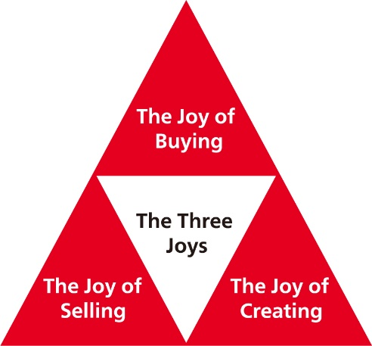

**Environmental Scan**  
An extensive examination of the outside variables that have a major influence on human resources (HR) planning is part of Honda Canada's environmental scan. The scan includes the legal and regulatory landscape, the economy, and technology developments—all of which have a significant impact on the formulation of strategic HR choices.

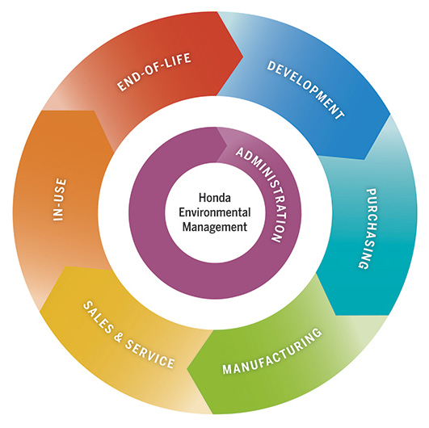

**ECONOMIC ENVIRONMENT**

1. **Changes in Currency Rates**  
   Issue: The price of imported materials and components might fluctuate greatly, which has an effect on total manufacturing costs.

Rationale: In order to lessen the negative effects of currency fluctuations on manufacturing costs, Honda Canada has to put strategic financial planning and risk management procedures into place.

1. **Economic Recessions**  
   Issue: Consumer spending power declines during economic downturns, which lowers the demand for new automobiles on the market.

Rationale: In order to sustain profitability and guarantee company continuity, Honda must make arrangements for flexible personnel and possible cost-cutting actions in advance of economic downturns.

1. **Changes in Interest Rates**Issue: Shifts in interest rates may have an effect on financing expenses for the business and its clients, which may have an effect on total revenue and profitability.  
   Rationale: Honda can preserve its competitiveness in the market and efficiently handle financial risks by closely observing changes in interest rates and modifying pricing tactics accordingly.

**Technological improvements:** To maintain a competitive advantage, the workforce must continuously upskill and

**Technological Advancements**

1. **Quick Changes in Technology**

Issues : The workforce has to be continuously retrained and upskilled due to the quick technological improvements in the automobile sector.

Rationale : By funding extensive training initiatives, Honda can make sure that its personnel is always creative and capable of staying up to date with emerging technologies.

1. **Enhanced Automation**

Issues : As industrial processes become more automated, workers must adjust to new procedures and technology.

Rationale : Honda will be able to sustain production efficiency and stimulate innovation by placing a strong emphasis on technical proficiency and flexibility through focused training programs.

1. **Investment in R&D**

Issue: In order to stay ahead of the competition, Honda has to continue investing in research and development, particularly in the areas of artificial intelligence (AI) and electric vehicles (EVs).

Rationale: Attracting and retaining top talent in technology and engineering is essential to maintaining innovation and a competitive edge in the market..

**Regulatory and Legal Aspects**

1. **Rules Regarding the Environment**

Issue: Product offers and production procedures are directly impacted by strict environmental restrictions, such emissions limitations.

Rationale: In order to maintain compliance with environmental regulations, Honda should take a proactive approach to employee training and development. This would help the company stay out of legal hot water and promote a sustainable business model.

1. **Regulations pertaining to Labour and Employment**

Issue: HR policies and procedures may be impacted by modifications to labour laws and employment rules, necessitating ongoing adaption.

Rationale: Ensuring compliance and reducing legal risks may be achieved by keeping abreast of legislative developments and implementing them into HR policy.

1. **Tariffs and Trade Regulations**

Issue: Tariffs and trade laws can have an effect on supply chain plans, which can change the price and accessibility of materials.

Rationale: Honda will be able to reduce the risks brought on by regulatory changes and preserve a stable supply chain by creating backup plans and strategic sourcing options.

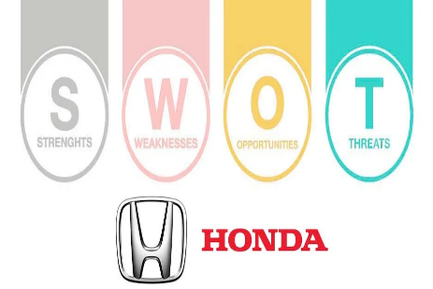

**SWOT Analysis for Honda Canada**

**Strengths:**

**High Brand Reputation and Customer Loyalty**

Issue: Using a strong brand to draw in new business and keep existing ones.

Rationale: Strong customer loyalty gives Honda a competitive advantage and increases market share, allowing it to sustain high sales even under difficult market circumstances.

**Developed Online Presence**

Issue: Honda offers a wide network of service facilities and dealerships throughout Canada.

Rationale: The extensive distribution network guarantees easy access to goods and services, enhancing the general pleasure and experience of customers.

**Innovation and advanced in Advanced Manufacturing**Problem: Honda is well known for its innovative use of technology in the manufacture of vehicles.   
Rationale: Honda's sophisticated production capabilities allow it to meet the growing demand for electric and hybrid vehicles, bolstering its dominant position in the industry.

**Weakness:**

**Elevated Costs of Operations**

Issue: The expenses related to cutting-edge manufacturing technology and processes.

Rationale: In order to preserve profitability, high operating costs necessitate cost-cutting measures and efficiency enhancements.

**Lack of Reliance on a Few Models**

Problem: Only a few flagship models account for the majority of Honda's sales.

Rationale: By diversifying the product range, a company may reduce its reliance on market and client preference swings while ensuring a steady stream of revenue.

**Challenges to prompt adaptation**

The rapid shifts in consumer preferences and technological advancements present challenges to prompt adaptation.

Rationale: To maintain competitiveness and seize new opportunities, organisations must become more agile and responsive to changes in the market.

**Opportunities:**

**Expanding market for EVs**

Issue: Increasing the range of Honda electric cars.

Rationale: Honda will be better positioned in the market and see revenue growth if it takes advantage of the growing demand for environmentally friendly transportation.

**New Markets**

 issue : growing Honda's footprint in areas where the number of cars on the road is increasing.

Rationale: By pursuing possibilities in emerging nations, Honda may expand its income streams and broaden its customer base.

**Strategic Alliances**

Issue: Working with technological companies.

Rationale: Honda will remain at the forefront of technology innovation by collaborating with IT businesses to foster innovation in connection and autonomous driving technologies.

**Threats:**  
**intense Rivalry**

Issue: The car sector faces intense competition.

Rationale: To preserve market position and safeguard profit margins, differentiation via innovation and quality is crucial.

**Disruptions to the Supply Chain**

Issue: The dangers of international supply chain problems.

Rationale: By diversifying suppliers and creating robust supply chain methods, risks may be reduced and production can continue as usual.

**Volatility of the Economy**

Issue: Consumer expenditure on new automobiles is impacted by economic downturns.

Rationale: Honda will be able to manage economic uncertainty and maintain profitability by applying strategic cost control and diversifying its income streams.

**HR Strategy Priorities**

**1. Identifying and nurturing talent**  
Emphasis: Cutting-edge production and electric car innovation.  
Rationale: Promotes competitiveness and innovation.  
fills the skills gap for emerging technologies.  
strengthens the employer brand to draw in top candidates.  
 **2. Employee Engagement and Retention**  
Emphasis: Important engineering and technical positions.  
Rationale: Lowers churn and keeps important talent.  
raises worker satisfaction and engagement.  
lowers the expense of training and hiring.  
 **3. Diversity and Inclusion**  
Goals for diversity recruiting, training on unconscious bias, and assistance for employee resource groups are in focus.  
Rationale: Takes into account a variety of market categories.  
encourages originality and creativity.  
encourages a welcoming and upbeat work atmosphere.  
fulfils legal obligations and improves reputation.

**ACTION PLAN**

1. **Start a Targeted Recruitment Campaign with a Tech Talent Focus as the First Talent Acquisition and Development Action Item.**Problem: Filling the skills void in developing automotive technology.  
   Rationale: Top talent in fields like automation, artificial intelligence, and electric vehicle development may be drawn to Honda by emphasising the company's cutting-edge technology and creative initiatives.  
   **Steps:**1 Reach out to possible applicants via social media and online job sites.  
   2 Attend tech-related networking events and job fairs.  
   3 To draw in qualified experts, highlight Honda's creative projects.
2. **Program for Internal Training in Emerging Technologies**  
   Problem: Adapting to the quick advances in vehicle technology.  
   Rationale: Honda makes an investment in ongoing employee training to guarantee that their workforce is knowledgeable and creative.  
   **Steps**:1 Create an extensive training program with an emphasis on emerging technology.  
   2 Hold frequent seminars and training sessions.  
   3 Keep an eye on and assess training programs' efficacy.
3. **Create Cooperative and Internship Programs with Universities in Collaboration**  
   Problem: Creating a solid talent pipeline.  
   Rationale: Collaborating with colleges to provide co-ops and internships encourages early interest in the automotive sector and draws in future potential.  
   **Steps**: 1Form alliances with prestigious colleges.  
   2 In important disciplines, establish co-ops and internship programs.  
   3 Give pupils real-world experience and guidance.

**Employee Engagement and Retention**

1. **Examine and Revise the Pay Structure to Comply with Industry Standards**  
   Problem: Getting and keeping elite experts.  
   Rationale: Competitive pay packages will lower employee churn and raise job satisfaction.  
   **Actions**:1 Examine the present compensation plan in detail.  
   2 Compare the benchmark to industry norms.  
   3 Make the required changes to stay competitive.
2. **Program for Monthly Employee Recognition**  
   Problem: Employee engagement depends on recognition.  
   Rationale: Institutionalised reward systems foster a culture of gratitude and increase motivation.  
   **Actions**: 1 Create the standards for the monthly awards of recognition.  
   2 Tell the staff about the program and its advantages.  
   3 Reward and recognise exceptional work on a regular basis.

.



**3. Developed plans for professional growth**  
  
Problem: Outlining precise professional development routes.  
Rationale: Formal career development programs improve employee engagement and long-term retention.  
**Steps**:  
1 For a variety of professions, create thorough career development plans.  
2 Identify essential knowledge, experiences, and career trajectories.  
3 Provide tools and guidance for advancing your career.

**Diversity and Inclusion:**

1. **Establish Measurable Diversity Objectives and Report Frequently on Your Progress**

Problem: Building a multicultural staff.  
Rationale: Measurable, explicit diversity objectives promote responsibility and continuous growth.  
**Steps**: 1 Establish precise diversity goals and measurements.  
2 Put in place a tracking system to keep tabs on advancement.  
3 Provide regular updates on diversity-related projects and results.

**2. Diversity education is required**  
Problem: Encouraging a welcoming environment at work.  
Rationale: Unconscious bias training and inclusive leadership training promote respect and cooperation.  
**Steps**: 1 Create an extensive diversity education curriculum.  
2 Make attendance at training sessions a requirement for every employee.  
3 Evaluate the impact of training on the work environment.

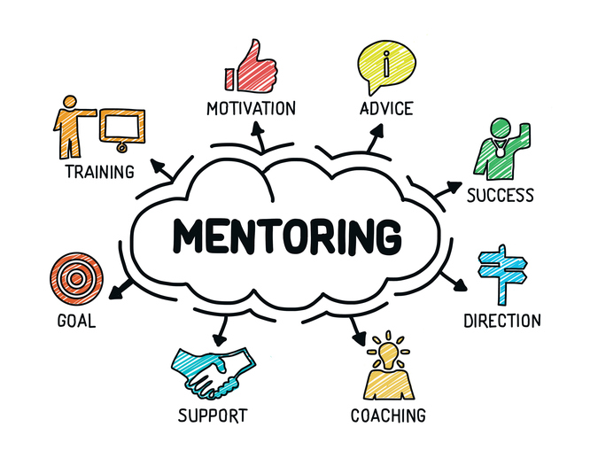

**Mentorship Programs for Under-represented Groups**  
Problem: Helping employees from under-represented groups.  
Rationale: Mentorship programs foster diversity at all organisational levels by offering beneficial networking, professional development, and leadership opportunities.  
**Action items:**

1 Locate possible mentees and mentors.  
2 Match mentors with under-represented staff members according to their interests and career aspirations.

3 Oversee ongoing mentorship sessions and monitor development.

References

Company overview | Honda in Canada. (n.d.)., <https://www.hondacanadamfg.ca/our-company/> <https://www.hondacanadamfg.ca/our-products/>

Corporate Strategy | Honda in Canada. (n.d.)., <https://global.honda/en/sustainability/integratedreport/corporate-strategy/>

[https://www.torquenews.com/1063/honda-slogan-promises-blue-skies-our-children#](https://www.torquenews.com/1063/honda-slogan-promises-blue-skies-our-children#:~:text=Honda%20engineers%20used%20the%20phrase%20%22Blue%20Skies%20for,standards%20of%20the%201970s%20U.S.%20Clean%20Air%20Act)

*Environmental Sustainability Initiatives | Honda in Canada*. (n.d.). <https://www.hondacanada.ca/environment>

*Honda in Canada: Our mission & corporate responsibility*. (n.d.). <https://www.hondacanada.ca/home>

Jurevicius, O. (2023, March 30). *SWOT analysis of Honda 2023*. Strategic Management Insight. <https://strategicmanagementinsight.com/swot-analyses/honda-swot-analysis/>

Mission Statement <https://mission-statement.com/honda/>



**ACADEMIC HONESTY STATEMENT**

We, Manpreet Kaur, Baishali Kakati, Gurwinder Singh and Sukhminder Kaur *(print name),* affirm that this assignment represents entirely my own efforts.

**Assignment Name:** Strategic Planning

By **checking the boxes** below and **signing** this form I **confirm** that I:

* Acknowledge including reference list entries without corresponding in-text citations is **plagiarism.**
* Acknowledged the use of another’s ideas with accurate in-text citations.
* Acknowledge that If I used the words of another (e.g., author, instructor, information source – including AI), I have acknowledged this with quotation marks (or appropriate indentation for quotations of more than 40 words) **and** proper in-text citation.
* Acknowledge this is the first time I have submitted this assignment (in whole or in part) for credit.
* Acknowledge I have kept my work to myself and did not share answers/content with others, unless otherwise directed by my instructor.
* Acknowledge I have reviewed the Georgian College Library Citing Guide at <https://library.georgiancollege.ca/citing>
* Acknowledge I understand the consequences of violating the College’s Academic Integrity Policies as outlined under “Academic Rights and Responsibilities” <https://cat.georgiancollege.ca/academic-regulations/integrity/>

**By signing this form I agree that the statements above are true AND acknowledge that:**

***The use of Generative AI, including but not limited to, ChatGPT is strictly prohibited for this assignment****. A Turnitin report indicating the use of such technology will automatically result in a failing and academic misconduct. I acknowledge that AI generative technology has NOT been used in this assignment.*

*Signature* *(On behalf of the group)*

*Student Name: Manpreet Kaur (200554128)*

*Baishali Kakati (200567296)*

*Gurwinder Singh (200557497)*

*Sukhminder Singh (200582090)*

For a complete list of academic regulations click this link: <https://www.georgiancollege.ca/admissions/academic-regulations/>

**If you have questions or concerns with the statements above, please consult the course Professor prior to the submission date**